**axis_readout_v2**

Introduction

Compare to axis_pfb_readout_v2, this ip can only demodulate a frequency at a time, but the max frequency it can demodulate could be much higher than that of axis_pfb_readout_v2 limited only by the max sampling rate of ADC.

Specs

* Frequency (fs is sampling rate of ADC): max input frequency is fs; min input frequencies may be limited by external RF circuits (e.g. baluns).

How to include it in firmware (zcu216, vivado2020.2)

IP core settings (double click on the ip):

* “Fullspeed Output” checked

RFDC (Zynq Ultrascale+ RF Data Converter) DAC settings:

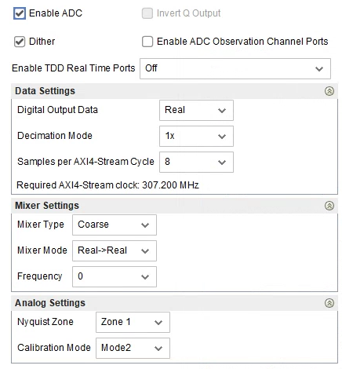

RFDC ADC tile clocking settings:



* Note that the relation between fs and faclk ( = fclk_adc2 below) need to be fs = 8 * faclk, where 8 is number of DDS inside the ip, which is not desinged to configurable. In this example, faclk = 307.2, fs = 2457.6 MHx, which satisfies the relation.

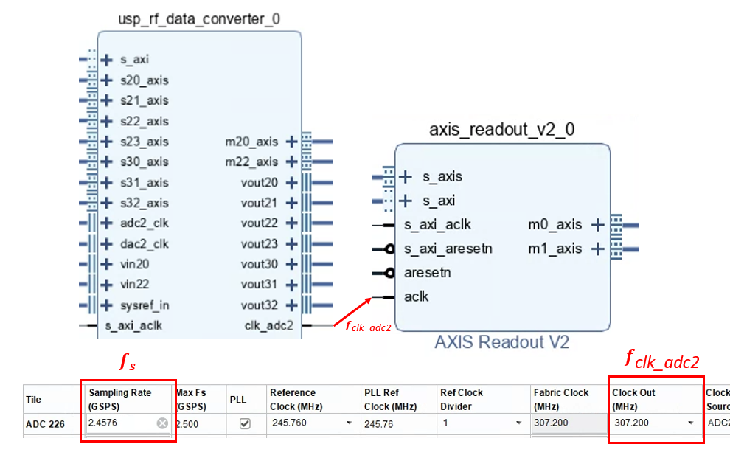

Wirings:

* For full details, you can re-create the vivado block design using the scripts (bd_216 … .tcl, proj_216 … .tcl) at:

<https://github.com/Ri-chard-Wu/thesis/tree/master/codes/full-speed-ro-sg-bd-scripts-216>

If you don’t know how to use the scripts, see the section *export & re-create vivado block design*.

